**REPORT**

**BUILDING UNSUPERVISED MODEL FOR PROPERTY FRAUD IN NEW YORK CITY**

**Prepared for:**

Professor Stephen Coggeshall

**Prepared by:**

CHEN, Siqi

GUO, Qianfei

HUNG, Kai-Ling

JIA, Xuerong

LIN, Xiaoyan

TSAI, Pei Yu

February 20, 2019

**Table of Content**

1 Executive Summary 3

1.1 Work Performed 3

1.2 Results 3

2 Description of Data 4

2.1 Data Source 4

2.2 Summary of Numerical Fields 4

2.3 Summary of Categorical Fields 4

2.4 Overview of NYC Property 5

3 Data Cleaning - Filling Missing Values 6

3.1 Missing Fields 6

3.2 Steps for ZIP 6

3.3 Steps for STORIES 7

3.4 Steps for FULLVAL, AVLAND, AVTOT 7

3.5 Steps for LTFRONT，LTDEPTH，BLDFRONT, BLDDEPTH 7

4 Creating Variables 8

4.1 Creating 45 New Variables 8

4.2 Definitions of the 45 Variables 8

5 Dimensionality Reduction 9

5.1 Principal Component Analysis (PCA) 9

5.2 Z-scaling 10

6 Algorithms 10

6.1 Manhattan Distance Score 10

6.2 Autoencoder Score 11

6.3 Weighted Score 11

7 Results 11

8 Conclusions 16

8.1 Steps Performed 16

8.2 Results 16

8.3 Recommendations 16

9 Appendix 17

# Executive Summary

## 1.1 Work Performed

The goal of our project is to build an unsupervised fraud model to analyze NYC property data to determine whether there is indication of fraud. We obtained the Property Valuation and Assessment Data of New York City from the NYC Open Data website, and then performed the following steps.

1. Filled the missing values for nine key fields;
2. Created 45 new variables;
3. Z-scaled the data so that they are on the same footing;
4. Conducted PCA to reduce dimensionality of the data to seven PCs;
5. Z-scaled the seven PCs again;
6. Combined the Z-scores with a heuristic algorithm to arrive at Score 1;
7. Train an autoencoder on the seven Z-scaled PCs to reproduce seven new PCs. Score 2 would be the difference between the original input records and the autoencoder output records;
8. Combine Score 1 and Score 2 using weighted average rank orders to get the final score;
9. Sorted the final score on a descending order and further investigated into records with top 10 highest fraud scores.

## 1.2 Results

Our analysis found that there are mainly three causes for the anomalies we noted:

1. Unusually small building or lot sizes. For instance, building front and building depth with the value of zero or one foot;
2. Unusually high values of lot sizes; and
3. Unusually high values of the property in comparison with other properties in the same borough, zip code or tax class. The unusual values are typically in FULLVAL, AVLAND and AVTOT fields.

Further research and inquiries are needed to verify whether the anomalies we noticed were caused by human error, plausible explanations[1], or fraudulent activities.

# Description of Data

## 2.1 Data Source

The NYC Property Valuation and Assessment Data used to build our fraud model was obtained from the NYC Open Data website[2]. The data was originally provided by Department of Finance on September 2, 2011, and the most recently revised on September 10, 2018. This dataset has 32 fields and 1,070,994 records. Dataset represents NYC properties assessments for purpose of calculating Property Tax, Grant eligible properties Exemptions and/or Abatements. Data was collected and entered into the system by City employees including Property Assessors, Property Exemption specialists, ACRIS reporting, Department of Building reporting, etc.

## 2.2 Summary of Numerical Fields

This dataset has 14 numerical fields, which are summarized in Table 1 below. Fields that are marked red are fields of low percentage populated.

**Table 1 – Summary of Numerical Fields**

|  |  |  |  |  |  |  |  |  |
| --- | --- | --- | --- | --- | --- | --- | --- | --- |
| Field Name | Count | Unique Values | Value with Zero | % Populated | Mean | Max | Min | SD |
| LTFRONT | 1,070,994 | 1,297 | 169,108 | 100.00% | 3.66E+01 | 1.00E+04 | 0.00E+00 | 7.40E+01 |
| LTDEPTH | 1,070,994 | 1,370 | 170,128 | 100.00% | 8.89E+01 | 1.00E+04 | 0.00E+00 | 7.64E+01 |
| STORIES | 1,014,730 | 112 | n/a | 94.75% | 5.01E+00 | 1.19E+02 | 1.00E+00 | 8.37E+00 |
| FULLVAL | 1,070,994 | 109,324 | 13,007 | 100.00% | 8.74E+05 | 6.15E+09 | 0.00E+00 | 1.16E+07 |
| AVLAND | 1,070,994 | 70,921 | 13,009 | 100.00% | 8.51E+04 | 2.67E+09 | 0.00E+00 | 4.06E+06 |
| AVTOT | 1,070,994 | 112,914 | 13,007 | 100.00% | 2.27E+05 | 4.67E+09 | 0.00E+00 | 6.88E+06 |
| EXLAND | 1,070,994 | 33,419 | 491,699 | 100.00% | 3.64E+04 | 4.67E+09 | 0.00E+00 | 3.98E+06 |
| EXTOT | 1,070,994 | 64,255 | 432,572 | 100.00% | 9.12E+04 | 2.67E+09 | 0.00E+00 | 6.51E+06 |
| BLDFRONT | 1,070,994 | 612 | 228,815 | 100.00% | 2.30E+01 | 7.58E+03 | 0.00E+00 | 3.56E+01 |
| BLDDEPTH | 1,070,994 | 621 | 228,853 | 100.00% | 3.99E+01 | 9.39E+03 | 0.00E+00 | 4.27E+01 |
| AVLAND2 | 282,726 | 58,592 | n/a | 26.40% | 2.46E+05 | 2.37E+09 | 3.00E+00 | 6.18E+06 |
| AVTOT2 | 282,732 | 111,361 | n/a | 26.40% | 7.14E+05 | 4.50E+09 | 3.00E+00 | 1.17E+07 |
| EXLAND2 | 87,449 | 22,196 | n/a | 8.17% | 3.51E+05 | 2.37E+09 | 1.00E+00 | 1.08E+07 |
| EXTOT2 | 130,828 | 48,349 | n/a | 12.22% | 6.57E+05 | 4.50E+09 | 7.00E+00 | 1.61E+07 |

## 2.3 Summary of Categorical Fields

This dataset has 18 categorical fields, which are summarized in Table 2 below. Fields that are marked red are fields of low percentage populated.

**Table 2 – Summary of Categorical Fields**

| Field Name | Count | Unique Values | Most Common | % Populated |
| --- | --- | --- | --- | --- |
| RECORD | 1,070,994 | 1,070,994 | Uniform Distributed | 100.00% |
| BBLE | 1,070,994 | 1,070,994 | Uniform Distributed | 100.00% |
| B | 1,070,994 | 5 | 4(33.43%) | 100.00% |
| BLOCK | 1,070,994 | 13,984 | 3944(0.36%) | 100.00% |
| LOT | 1,070,994 | 6,366 | 1(2.28%) | 100.00% |
| EASEMENT | 4,636 | 13 | E(89.47%) | 0.43% |
| OWNER | 1,039,249 | 863,348 | PARKCHESTER PRESERVAT (0.58%) | 97.04% |
| BLDGCL | 1,070,994 | 200 | R4(13.06%) | 100.00% |
| TAXCLASS | 1,070,994 | 11 | 1(61.69%) | 100.00% |
| EXT | 354,305 | 4 | G(75.35%) | 33.08% |
| EXCD1 | 638,488 | 130 | 1017(0.1%) | 59.62% |
| STADDR | 1,070,318 | 839,281 | 501 SURF AVENUE(0.08%) | 99.94% |
| ZIP | 1,041,104 | 197 | 10314(2.36%) | 97.21% |
| EXMPTCL | 15,579 | 15 | X1(44.37%) | 1.45% |
| EXCD2 | 92,948 | 61 | 65777(6.1%) | 8.68% |
| PERIOD | 1,070,994 | 1 | FINAL | 100.00% |
| YEAR | 1,070,994 | 1 | 2010/11 | 100.00% |
| VALTYPE | 1,070,994 | 1 | AC-TR | 100.00% |

## 2.4 Overview of NYC Property

The histograms and bar charts below give a high-level understanding of the sizes and prices of the NYC property in our dataset. Please refer to the Appendix for a full DQR.

1. FULLVAL – the total market value of the property
2. AVLAND – the market value of the land

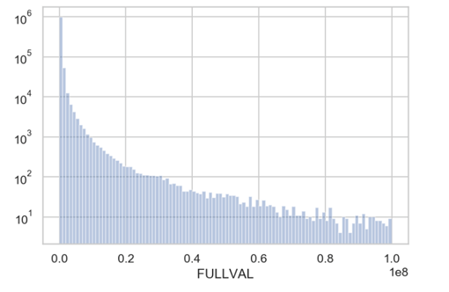

1. AVTOT – assessed value of the property

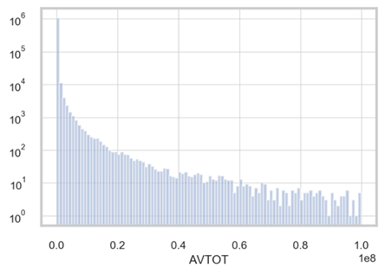

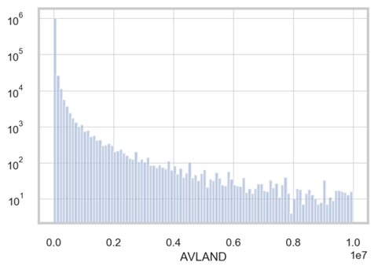

1. LTFRONT – lot frontage in feet

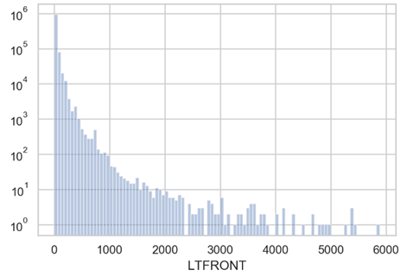

1. LTDEPTH – lot depth in feet

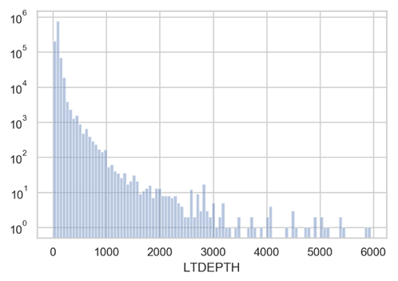

1. BLDFRONT – building frontage in feet

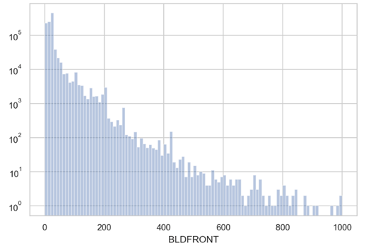

1. BLDDEPTH – building depth in feet

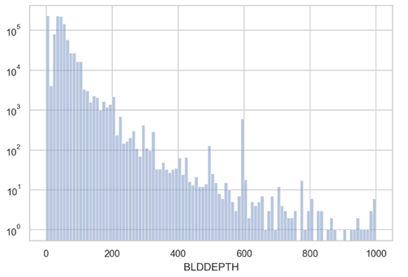

1. STORIES – number of floors in each building

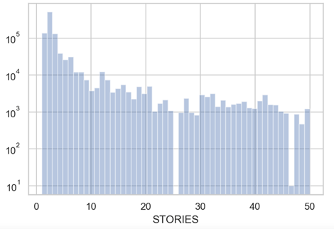

# Data Cleaning - Filling Missing Values

## 3.1 Missing Fields

To perform analysis on the NY property data, we need to fill in missing values for fields listed below. The goal is to fill in these fields with innocuous values that would not set off the alarm.

* ZIP
* STORIES
* FULLVAL, AVLAND, AVTOT
* LTFRONT，LTDEPTH，BLDFRONT, BLDDEPTH

## 3.2 Steps for ZIP

1. Grouped by B and BLOCK, filled the missing values with the most frequent zip of the group. If there are less than 5 records in the group, left it as is;
2. Grouped by B and STADDR, filled the missing values with the most frequent zip of the group. If there are less than 5 records in the group, left it as is; and
3. Grouped by B, filled the missing values with the most frequent zip of the group.

## 3.3 Steps for STORIES

1. Grouped by TAXCLASS and ZIP, filled the missing values with the average STORIES of the group. If there are less than 10 records in the group, left it as is;
2. Grouped by BLOCK, filled the missing values with the average STORIES of the group. If there are less than 5 records in the group, left it as is; and
3. Grouped by ZIP, filled the missing values with the average STORIES of the group.

## 3.4 Steps for FULLVAL, AVLAND, AVTOT

1. Grouped by ZIP, STORIES, TAXCLASS, Lot Area (LOTFRONT times LOTDEPTH) when Lot Area value is larger than 4 and smaller than 10,000; and then grouped by Building Area (BLDFRONT times BLDDEPTH) when Building Area is larger than 4 and smaller than 5,000, filled the missing values with the average value of the group. If there are less than 10 records in the group, left it as is;
2. Grouped by ZIP, STORIES, TAXCLASS, Lot Area, and filled the missing values with the average value of the group. If there are less than 10 records in the group, left it as is;
3. Grouped by ZIP, STORIES, TAXCLASS, Building Area, filled the missing values with the average value of the group. If there are less than 10 records in the group, left it as is;
4. Grouped by ZIP, TAXCLASS, Lot Area, and Building Area, filled the missing values with the average value of the group. If there are less than 10 records in the group, left it as is;
5. Grouped by ZIP, TAXCLASS, and Building Area, filled the missing values with the average value of the group. If there are less than 10 records in the group, left it as is;
6. Grouped by ZIP, TAXCLASS, and Lot Area, filled the missing values with the average value of the group. If there are less than 10 records in the group, left it as is;
7. Grouped by TAXCLASS, ZIP, and STORIES, filled the missing values with the average value of the group. If there are less than 10 records in the group, left it as is;
8. Grouped by ZIP, and STORIES, filled the missing values with the average value of the group. If there are less than 10 records in the group, left it as is;
9. Grouped by ZIP, filled the missing values with the average value of the group. If there are less than 10 records in the group, left it as is; and
10. Grouped by STORIES, filled the missing values with the average value of the group.

## 3.5 Steps for LTFRONT，LTDEPTH，BLDFRONT, BLDDEPTH

1. Created a new variable, defined it as the average value of FULLVAL, AVLAND and AVTOT, and transformed it into reasonable bin number;
2. Grouped by ZIP, STORIES, TAXCLASS and the bin number, filled the missing values with the average value of the group. If there are less than 10 records in the group, left it as is;
3. Grouped by STORIES, TAXCLASS and the bin number, filled the missing values with the average value of the group. If there are less than 10 records in the group, left it as is.
4. Grouped by TAXCLASS and the bin number, filled the missing values with the average value of the group. If there are less than 10 records in the group, left it as is;
5. Grouped by STORIES and the bin number, filled the missing values with the average value of the group. If there are less than 10 records in the group, left it as is; and
6. Grouped by TAXCLASS, filled the missing values with the average value of the group.

# Creating Variables

## 4.1 Creating 45 New Variables

The goal is to build fraud model to identify anomalous values in the fields such as FULLVAL, AVTOT and AVLAND. To that end, we need to create variables and normalize the variables so that each record can be compared with similar properties on a scaled basis. We created 45 variables for each record and the steps for creating these 45 variables are as follows:

1. Created three measurements of the square footage of each property;

• lotarea = LTFRONT * LTDEPTH

• bldarea = BLDFRONT * BLDDEPTH

• bldvol = bldarea* STORIES

1. Normalized FULLVALUE, AVTOT, AVLAND, respectively, by the lotarea, bldarea and bldvol for each record;
2. Calculated nine ratios of value per square foot for each record;
3. Grouped ratios by zip5, zip3, taxclass, borough and all, in order to compare the ratios with properties under similar condition or classification;
4. Calculated the averages of the nine ratios for each group; and
5. Divided each of the nine ratios by the average ratio in that group based on zip5, zip3, taxclass, borough.

## 4.2 Definitions of the 45 Variables

Each of the 45 variables is an indicator of how the record’s value per square foot deviated from the average of properties within its group. Refer to Table 3 below for the definition of the new 45 variables created.

**Table 3 – Definitions of the 45 Variables**

| Variable | Definition |
| --- | --- |
| V1 | FULLVAL per square footage of LOT compared to the average ratio in same zip5. |
| V2 | FULLVAL per square footage of LOT compared to the average ratio in same zip3. |
| V3 | FULLVAL per square footage of LOT compared to the average ratio in same taxclass. |
| V4 | FULLVAL per square footage of LOT compared to the average ratio in same borough. |
| V5 | FULLVAL per square footage of LOT compared to the average ratio. |
| V6 | FULLVAL per square footage of Building compared to the average ratio in same zip5. |
| V7 | FULLVAL per square footage of Building compared to the average ratio in same zip3. |
| V8 | FULLVAL per square footage of Building compared to the average ratio in same taxclass. |
| V9 | FULLVAL per square footage of Building compared to the average ratio in same borough. |
| V10 | FULLVAL per square footage of Building compared to the average ratio. |
| V11 | FULLVAL per square footage of Total Building compared to the average ratio in same zip5. |
| V12 | FULLVAL per square footage of Total Building compared to the average ratio in same zip3. |
| V13 | FULLVAL per square footage of Total Building compared to the average ratio in same taxclass. |
| V14 | FULLVAL per square footage of Total Building compared to the average ratio in same borough. |
| V15 | FULLVAL per square footage of Total Building compared to the average ratio. |
| V16 | AVLAND per square footage of LOT compared to the average ratio in same zip5. |
| V17 | AVLAND per square footage of LOT compared to the average ratio in same zip3. |
| V18 | AVLAND per square footage of LOT compared to the average ratio in same taxclass. |
| V19 | AVLAND per square footage of LOT compared to the average ratio in same borough. |
| V20 | AVLAND per square footage of LOT compared to the average ratio. |
| V21 | AVLAND per square footage of Building compared to the average ratio in same zip5. |
| V22 | AVLAND per square footage of Building compared to the average ratio in same zip3. |
| V23 | AVLAND per square footage of Building compared to the average ratio in same taxclass. |
| V24 | AVLAND per square footage of Building compared to the average ratio in same borough. |
| V25 | AVLAND per square footage of Building compared to the average ratio. |
| V26 | AVLAND per square footage of Total Building compared to the average ratio in same zip5. |
| V27 | AVLAND per square footage of Total Building compared to the average ratio in same zip3. |
| V28 | AVLAND per square footage of Total Building compared to the average ratio in same taxclass. |
| V29 | AVLAND per square footage of Total Building compared to the average ratio in same borough. |
| V30 | AVLAND per square footage of Total Building compared to the average ratio. |
| V31 | AVTOT per square footage of LOT compared to the average ratio in same zip5. |
| V32 | AVTOT per square footage of LOT compared to the average ratio in same zip3. |
| V33 | AVTOT per square footage of LOT compared to the average ratio in same taxclass. |
| V34 | AVTOT per square footage of LOT compared to the average ratio in same borough. |
| V35 | AVTOT per square footage of LOT compared to the average ratio. |
| V36 | AVTOT per square footage of Building compared to the average ratio in same zip5. |
| V37 | AVTOT per square footage of Building compared to the average ratio in same zip3. |
| V38 | AVTOT per square footage of Building compared to the average ratio in same taxclass. |
| V39 | AVTOT per square footage of Building compared to the average ratio in same borough. |
| V40 | AVTOT per square footage of Building compared to the average ratio. |
| V41 | AVTOT per square footage of Total Building compared to the average ratio in same zip5. |
| V42 | AVTOT per square footage of Total Building compared to the average ratio in same zip3. |
| V43 | AVTOT per square footage of Total Building compared to the average ratio in same taxclass. |
| V44 | AVTOT per square footage of Total Building compared to the average ratio in same borough. |
| V45 | AVTOT per square footage of Total Building compared to the average ratio. |

# Dimensionality Reduction

## 5.1 Principal Component Analysis (PCA)

The 45 newly created variables are on different scale and correlated with each other to certain extent. Therefore, we performed Principal Component Analysis to reduce dimensionality and correlations before calculating the final fraud score. Z-scaling can convert variables to same scale and same unit to make the correlation matrix for applying PCA.

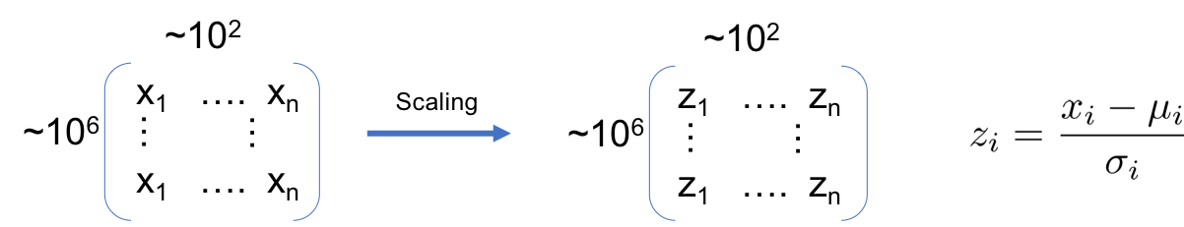

PCA uses an [orthogonal transformation](https://en.wikipedia.org/wiki/Orthogonal_transformation) to convert a set of observations of possibly correlated variables into a set of values of [linearly uncorrelated](https://en.wikipedia.org/wiki/Correlation_and_dependence) variables called principal components. The first principal component has the largest possible [variance](https://en.wikipedia.org/wiki/Variance), and each succeeding component in turn has the highest variance possible under the constraint that it is [orthogonal](https://en.wikipedia.org/wiki/Orthogonal) to the preceding components.

The PCA produced a reduced number of variables to seven Principal Components (‘PCs’). These seven PCs are able to explain 87% of variance.

## 5.2 Z-scaling

After reducing 45 variables to 7 PCs, we scaled them again so that the outlier records would get unusually large z-scores and thus stand out from the population.

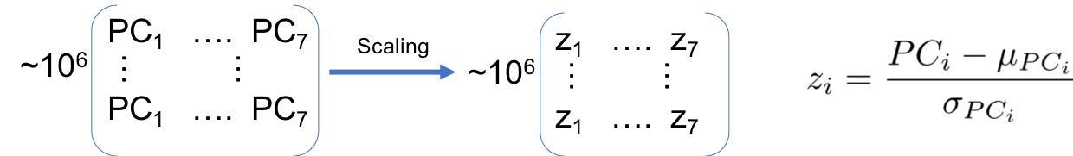

# Algorithms

## 6.1 Manhattan Distance Score

After Dimensionality Reduction, all values for all records are z-scaled. We call these z-scaled variables z-scores. We add up these z-scores of each record, without letting them cancel each other out.

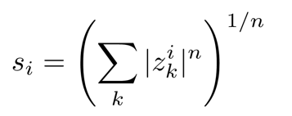 , n = 1

When a value is unusual, its z-score would be unusual, so the sum of z-sores shows the distance of the value from the origin.

## 6.2 Autoencoder Score

An autoencoder is a model trained to output the original vector input. We train an autoencoder on the entire data set. The model will learn to reproduce the data records as well as possible, and will learn the nature of the bulk of the data.

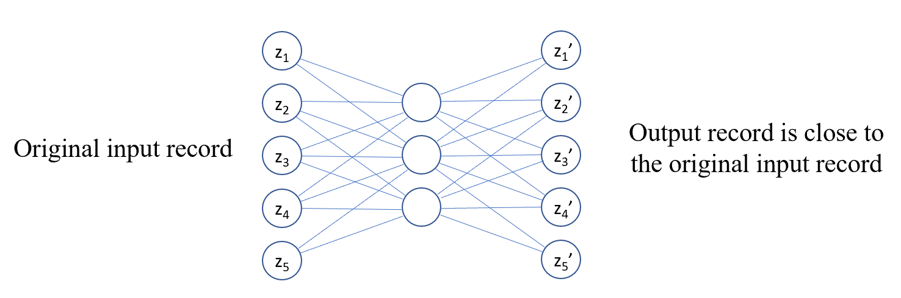

The Autoencoder focuses on the majority of the data. When a value is abnormal, the autoencoder does a poor job reproducing the value. The records that aren’t reproduced well are what we’re looking for. After the model is trained, the difference between the original input vector and the model output vector is the fraud score for that record.

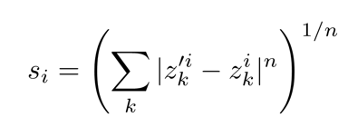, n = 1

## 6.3 Weighted Score

To scale two scores to the same level, we use quantile binning method. For each score, we replace the score with the record’s rank order after sorting by the score. Based on the distribution of scores, we decided to set our weighted score a linear combination of the two binned scores mentioned above.

Weighted Score = 0.5 * Manhattan Distance Score + 0.5 * Autoencoder Score

# Results

We sorted the records by fraud score in a descending order and selected the records with top 10 highest scores. Below is an overview of the distribution of fraud scores from both methods. Fraud score calculated based on z-scores algorithm exhibited right-skewed distribution (refer to the illustrations below). We examined the score from the perspective of both Manhattan distance and Euclidean distance. As expected, most of the records had low fraud scores and there were a few outliers relative to the number of total records.

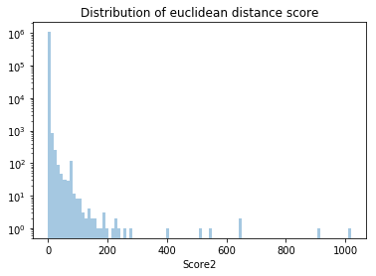

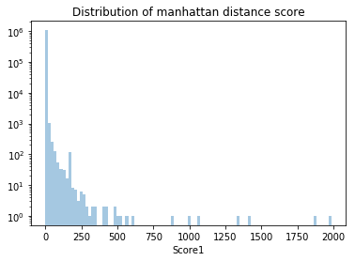

The distribution of fraud scores calculated using autoencoder algorithm also had a right skew (refer to the illustrations below).

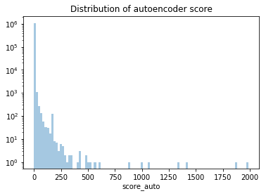

For weighted average score, we allotted 50% and 50% weights to scores obtained via autoencoder and Z-scaling, respectively. Distribution of weighted score fraud score has the approximately same pattern as the three above.

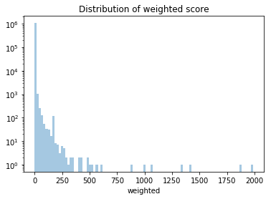

We manually examined the records with high fraud scores. Some properties are owned by government properties and universities. Although these properties are anomalies on several fronts, we know that government properties, parks and universities have very low risk of tax fraud. The top candidates for potential tax fraud have been listed below.

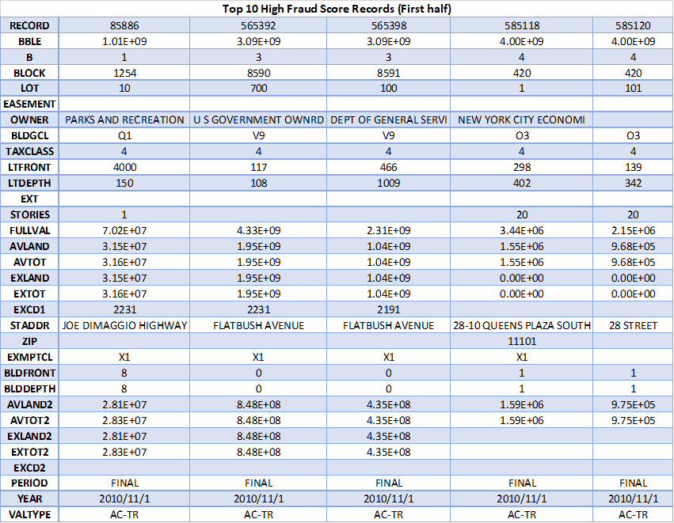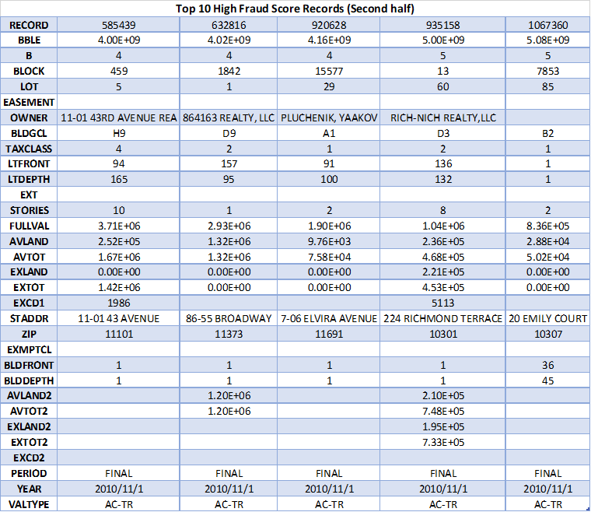

Clearly, for some of these records, the full value is exceptionally high. Further scrutiny reveals that such records have no information about lot front, lot depth, etc. For some other records, the full value of the property per build area is either excessively high or low. Since, a lot of these properties are owned by real estate firms, we can infer that either the properties owned by them are significantly different from an average property or they might be exploiting loopholes (and/or committing potential tax fraud) in the property tax law.

Record No. 632816: This property only has a one-story building and its full value is about $3M. This results in a very high full value per unit building volume, which indicate that there might be some fraud.



Record No. 1067360: The building front and depth of this property are both 1 and it has very high assessed value of land per unit lot area. It’s value of land per unit lot area is unusually high compared with other properties which have same TAXCLASS in the same zip code. Besides the property has missing owner name, which increase its probability of fraud.



Record No. 85886: This property is owned by New York government department of parks and recreation. The building front and depth of this property are both 8 but the lot area is 6e+05. The full value per unit lot area is unusually high.



Record No. 565392: This property is owned by New York government. This record has no BLDFRONT, BLDDEPTH, zip and stories data. Besides, FULLVAL, AVLAND and AVTOT are billions of dollars, unusually high with respect to its TAXCLASS, LTFRONT and LTDDEPTH.



Record No. 565398: This property is owned by New York government department of general service. FULLVAL, AVLAND and AVTOT are billions of dollars, unusually high with respect to its TAXCLASS, LTFRONT and LTDDEPTH.



Record No. 585118: This property is owned by New York government department of economics. For this property, average land per unit building volume and full value per unit building volume seems very high.



Record No. 585439: For this property, average land per unit building volume and full value per unit building volume seems very high.



Record No. 585120: The front and depth of this building is 1, which is too small as compared to its value $2.1m and 20 stories. Besides, average land per unit building volume and full value per unit building volume seems very high.



Record No. 920628: The front and depth of this building is 1. Small front and depth, only 2 stories and the $1.9m full value does not match perfectly. While the total market value and land value are too low. Besides, contrary to the small front and depth, the building has at least 1,902 ft² volume according to other resource.



Record No. 935158: The front and depth of this building is 1, which is too small as compared to its value $10.4m, 136 lot front, 132 lot depth and 8 stories. Probably because the old data was not updated since the building was built in 2012.



# Conclusions

## 8.1 Steps Performed

1. **DQR and Data Cleaning**: We started with exploratory analysis of the data which included descriptive analysis, data visualization, correlation analysis, missing data analysis, etc. We then cleaned up the data by filling in missing values;
2. **Creating 45 Variables**: We created 45 new variables mainly based on seven fields: FULLVAL, AVLAND, AVTOT, BLDFRONT, BLDDEPTH, LTFRONT, LTDEPTH, etc;
3. **Z-scaling**: We scaled the 45 new variables;
4. **Principal Component Analysis**: PCA was conducted to reduce the 45 variables to seven PCs, which explained more than 87% of the variance. The PCA reduced dimensionally and removed correlation between different variables;
5. **Z-scaling (again)**: We z-scaled again on the seven PCs;
6. **Heuristic algorithm:** we combined model variables with a heuristic algorithm that utilizes the sum of absolute z-scores; and
7. **Autoencoder:** We used autoencoder to train themodel into reproduce the original data. the reproduction error being a measure of the record’s unusualness and thus, a fraud score. Two approaches were used for calculating fraud scores – zscore and autoencoder algorithms.

## 8.2 Results

Fraud scores from both autoencoder and z-scores were skewed to the right. The algorithm produced high fraud scores to a lot of government properties and parks, which is expected because these properties generally have some missing values including missing building fronts and depths, have fewer stories and at the same time have high property value. Closer analysis of these records reveals that the full value of some of these properties is exceptionally high/low and they do not have complete property data (e.g., missing values in the lot depth field, lot front field, etc). For some other records, the full value of the property per building area is either excessively high or low.

## 8.3 Recommendations

If given more time, we recommend doing the following to improve our fraud model and further investigate the potential property fraud:

1. Fill missing data in a different way – There is a lot of missing data in original dataset. If we had more time, we would explore different ways of filling missing values to see if we could identify different anomalous records;
2. Seek opinions from Subject Matter Experts – Expert in fraud examination or in real estate industry could give us more insight in potential causes of the anomalies in the data, and help us form hypothesis with regard to the fraudulent activities;
3. Verify the anomalous data against third-party data – We could conduct site visit or internet research to verify the veracity of the anomalous data; and
4. Refine the model with more data – If we can get more information about property owners, crime rates, average income in the ZIP codes’ areas, etc., it may be useful in improving the model further.

# Appendix

1. For instance, Parks of Recreation’s lot size could be unusually big because a park would understandably have a big parking lot.
2. External link: <https://data.cityofnewyork.us/Housing-Development/Property-Valuation-and-Assessment-Data/rgy2-tti8>